**Suggested Reading:**  Secrets for a Successful Proposal [1], Instruction for Proposers [2], Proposal writing hints [3], *Professors as Writers: A self-Help Guide to Productive Writing* [4]

**Exercise:** Many find that one of the most difficult parts of the writing process is beginning. However, once started, writing can build its own momentum. Spontaneous writing is a method that allows you to get all your thoughts onto a page without worrying about quality, length, or even grammar. For this exercise, pick any topic that comes to mind (ex: the photoelectric effect, pokemon, your breakfast this morning, ect). Set a timer for 10 minutes and in the space below, write about anything and everything that comes to mind relating to that topic. Don’t stop to review a word choice, or question a sentence phrasing, or fix a spelling error. Most of all, do not think critically about the content you are writing. Instead focus on simply putting as much as possible down onto the page in that 10 minutes of time.

____________________________________________________________________________________________________________________________________________________________________________________________________________________________________________________________________________________________________________________________________________________________________________________________________________________________________________________________________________________________________________________________________________________________________________________________________________________________________________________________________________________________________________________________________________________________________________________________________________________________________________________________________________________________________________________________________________________________________________________________________________________________________________________________________________________________________________________________________________________________________________________________________________________________________________________________________________________________________________________________________________________________________________________________________________________________________________________________________________________________________________________________________________________________________________________________________________________________________________________________________________________________________________________________________________________________________________________________________________________________________________________________________________________________________________________________________________________________________________________________________________________________________________________________________________________________________________________________________________________________________________________________________________________________________________________________________________________________________________________________________________________________________________________________________________________________________________________________________________________________________________________________________________________________________________________________________________________________________________________________________________________________________________________________________________________________

Now that you’ve made it through the hard part, go back and reread what you wrote. Don’t feel discouraged if it comes across as clunky or even chaotic, as that is a totally natural result for an exercise like this. As you reread your work, try to take note of the different subtopics that you touch on. Even if they are far from fleshed out, what points or sections can you separate your writing into? For example, if you talked about your breakfast, perhaps first you started by listing what you had to eat, and then mentioned the process of making it. Perhaps you talked about how good or bad it tasted, or if you were able to finish it or were in a rush. In the space below, try to write 3 to 6 bullet points to encapsulate the different portions of your spontaneous writing. Now that you’ve identified them, ask yourself how you could expand on each of these if you were to go back and try this writing exercise again.

Spontaneous writing is useful for starting the writing process, but it can also be applied in other forms later in the writing process to help with revisions and writer's block. Interested students should take a look at reference [4] for a more in depth explanation and similar exercises.

Citations (note that these citations only relate to the recommended reading, not the citations used in the examples below):

[1] “The Advanced Photon Source a U.S. Department of Energy Office of Science User Facility.” *How to Wow! "Secrets'' for a Successful Proposal | Advanced Photon Source*, [www.aps.anl.gov/Users-Information/Getting-Started/User-Checklist/Apply-for-Time/Help-and-Reference/How-to-Wow-Secrets-for-a-Successful-Proposal](http://www.aps.anl.gov/Users-Information/Getting-Started/User-Checklist/Apply-for-Time/Help-and-Reference/How-to-Wow-Secrets-for-a-Successful-Proposal).

[2] “The Advanced Photon Source a U.S. Department of Energy Office of Science User Facility.” *Instructions for Proposers | Advanced Photon Source*, [www.aps.anl.gov/Users-Information/Getting-Started/User-Checklist/Apply-for-Time/Help-and-Reference/General-User-Proposal-Instructions/Instructions-for-Proposers](http://www.aps.anl.gov/Users-Information/Getting-Started/User-Checklist/Apply-for-Time/Help-and-Reference/General-User-Proposal-Instructions/Instructions-for-Proposers).

[3] Lang, Jonathan, et al. *Proposal Writing: Hints for Writing a Good Proposal & Getting Beam Time*. 24 June 2011, <https://neutrons2.ornl.gov/conf/nxs2011/pdf/lectures/NXSchool-PropStrategies-2011.pdf>.

[4] Boice, Robert. *Professors as Writers: a Self-Help Guide to Productive Writing*. New Forums Press, 1990.

**Foreword**: While proposals for different synchrotrons and even different beamlines will each have their own format, the content required for the proposal is usually very similar. We will use a proposal template for the Advanced Photon Source (APS) as a characteristic example, but everything discussed in this section should be easily transferable to beamline proposals at other synchrotron sources.

As an example, we’ll develop and present a proposal to study Cr(III)/Cr(VI) speciation, and in the assigned work you should write your own draft proposal on a topic of your own interest.

1. General Information: As the name suggests, this portion is for questions related to record keeping, safety, and other pertinent information needed by the proposal review panel, the synchrotron administration, and the safety review personnel. Take some time to come up with a descriptive title that both specifies the techniques needed and also the scientific goals or desired outcomes.

While all of these questions are important (especially the ones about safety, human subjects, etc.), all applicants should pay particular attention to the question “*Have you spoken to a beamline staff member?*”. Unless you have very strong experience at the desired beamline with exactly the needed apparatus, failure to contact a beamline is likely to lead to mistakes in your proposal and reduced likelihood of getting beamtime. This in turn means that you should start the beamtime application process at least a few weeks before deadline, given the busy schedules of beamline staff and the possibility that you’ll have to modify your proposal because of some new limitation or new opportunity at the beamline endstation.

All user application procedures will seek to take a census, of sorts, of the topics of research and some general classifications for reasons of safety, proprietary information, and other overall organizational concerns. Here’s our answers for the hypothetical proposal on Cr speciation:

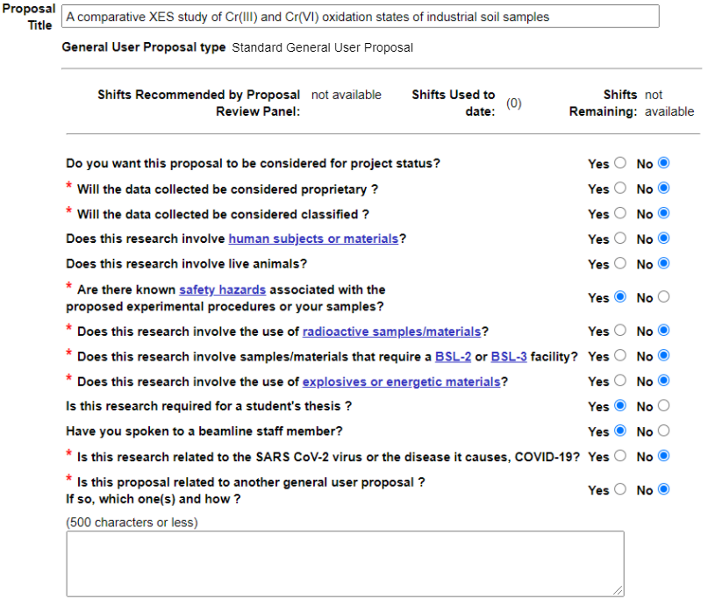

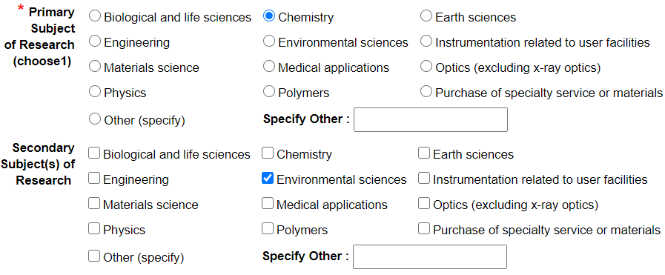

Instructions: Answer the general information questions as they relate to your own mock proposal topic.

1. Experimenters: You’ll need to specify the team that is involved in the proposed experiment. This is important! It helps the safety teams make sure that everyone coming to the synchrotron has completed necessary training, and also it helps the proposal review panel understand the larger team that is part of your effort. It is a good idea to include the names of, for example, supervisors, theory collaborators, and materials synthesis collaborators. The list of participants, and their roles and experience with synchrotron work, can usually be elaborated later in a proposal and strengthens the case for beamtime.

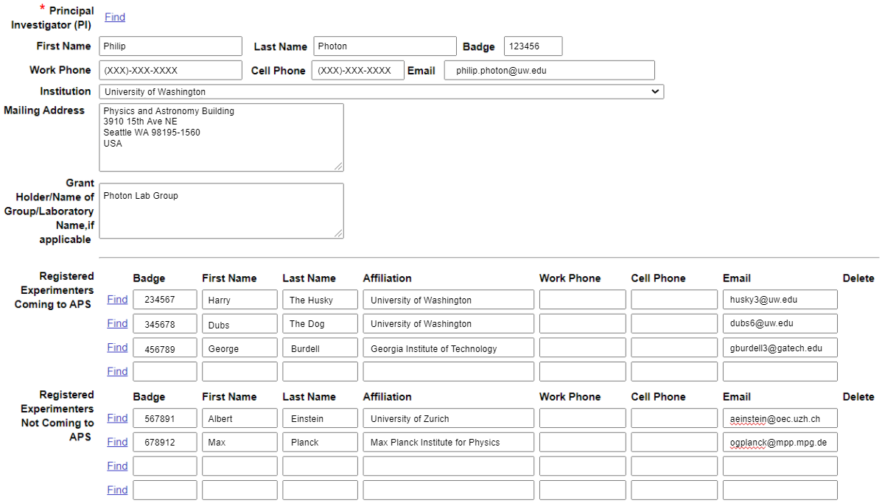

Instructions: List the names and contact information for the collaborators that will be included on your proposal, either coming to the synchrotron or working in support and collaboration. It is important to include a complete list of experimenters involved in the project who are not coming to the APS so that the review panel can see the full quality of the team involved in the project. For example, if a graduate student is filling out the GUP on behalf of a larger team, then it is especially important to include the advisor’s information and that of any senior collaborators. If significant members of your team are not registered with the synchrotron, you’ll have a chance to describe your team and its efforts later in the GUP.

1. Abstract of Proposed Research: There are always more proposed experiments than there is available space in a given year. For typical synchrotron XAS beamlines, the oversubscription is a factor of two to three. Consequently, it is extremely important to write a strong case for the science that you want to perform. In the APS format, there are two opportunities to make your argument -- in the abstract (which often is not short!), and in the later questions about scientific motivation and practical details of the study. At other light sources, the sections of the proposal will be different but it is still your job to make the same case.

There are many ways to write an abstract, but as a starting point we will use a standard 3 paragraph format. Note that the APS proposal format has a limit of 4000 characters, approximately 500-600 words. Below, we’ll give instructions for each paragraph and show our draft example. Then, in the space below, you should write your own corresponding paragraph.

Instructions: Each paragraph will have a prompt and a series of questions that should direct the flow and content of the overall abstract. These questions are designed to get you thinking about what to write for each paragraph, so do not feel that you must explicitly respond to each question. For each portion of the abstract, use the prompt/questions and the mockup as inspiration and a guide to help you write your own paragraph in the space provided. (Note: You should include references and can also add supporting documents such as figures, ect . . .) Note that in the example text we’ve started numbering citations from ‘1’, and that citations are specific to the example, and don’t connect to the citations for recommended reading in this section.

**Paragraph 1 (Context and Interest)**: What is the context of the larger field of research that your proposal falls into? How does the current interest in this field motivate your experiment?

Example:

*Cr(VI) is well known for its carcinogenic properties and has been classified as a hazardous substance by many international groups [1, 5]. While methods for determining Cr(VI) content already exist, they are susceptible to species interconversion and incomplete extraction [2], and have been found to systematically under-estimate the mass fraction of Cr(VI) in certain cases [4]. A preliminary study by our group has already demonstrated the capability of x-ray emission spectroscopy (XES) as a powerful tool for characterizing the Cr(VI)/Cr mass fraction with sufficiently small uncertainties for application to regulatory standards [3]. While our initial focus has been on speciation of Cr used in plastics, there is broader concern about Cr(VI) concentration other matrices including cements, coal ash, leather goods, soils, anti-corrosion coatings, mining ores, and paint sludge.*

Notice how, following common practice, we’ve included citations to prior work in the field. This can be very helpful for proposal review panel members. Typically, no member of the proposal review panel will be deep experts in your own research niche -- science is very large! Having citations to review articles and to prior work from your own team can be immensely helpful for that panel members to gain context. As a favor to the review panel, it would be good to include doi links directly to all cited articles. Now, in the space below, write your own ‘Context and Interest’ first paragraph (and collect your citations for future use, below):

**Paragraph 2 (Proposed Study and Relationship to Prior Work)**: Exactly what do you want to study, why, and how? How does this build on prior work by your group or prior work by others? What preliminary results do you have? You can greatly strengthen your proposal by tying your intended experiment to the work you have already done. This creates a logical throughline, making it easier for the committee to see the big picture of your proposal.

Example:

*We propose a study which builds upon our previous investigations Cr oxidation states within industrial plastics to instead look at soil samples. The demonstration of lab-based Cr XES [3] provides a strong potential standard test method for the future of environmental and safety regulation. However, there is need for further work on validating methodology, especially as concerns possible systematic errors that can only be addressed by having parallel measurements with fully independent analyses. Consequently, here we propose to measure the nonresonant core-to-core K*⍺ *XES, K*𝛽 *XES, the XANES, and the quite weak valence-to-core (VTC) XES for the soil samples and reference standards. Because of the low concentration of the Cr in the targeted soil samples, the XANES and VTC-XES cannot be measured in the lab. Quantitative analysis of the three complementary measurements performed on the same samples will be a powerful tool to firmly establish the use of advanced x-ray spectroscopies for this problem.*

Now, in the space below, write your own ‘Proposed Study and Relationship to Prior Work’ paragraph:

**Paragraph 3 (Tangible Outcomes)**: What will be the tangible consequences/outcome of your proposed experiment? What publishable data will it produce? What impact will this have on the field? How will it enable future work by your own group or others?

Example:

*We expect several tangible outcomes from the proposed work. First, the critical comparison of the three methods will establish a strong estimate of systematic errors from the lab-based XES measurement, which will be performed on the same samples. Second, the resulting publication will serve as an anchor not just for the use of such methods on soils but more generally will stand as an example for other speciation problems where reference standards are far less certain, such as very commonly occurs for catalysis studies, or where there is no single clear, strong signature in the XANES of the presence of a particularly moiety: the strong pre-edge peak from the tetrahedrally-coordinated Cr(VI) is an especially favorable case. Third, and perhaps having the broadest impact, a successful study might be a key step toward the incorporation of mail-in synchrotron use as part of a certified standard test method for the first time.*

Now, in the space below, write your own ‘Tangible Outcomes’ paragraph:

**Citations**: Note that for the APS format, the citations are collected in a section at the very end of the ‘questions’ section, which is where we will include ours.

1. Beamtime Request: In the APS format, the next step is the beamtime request where you specify the desired beamline, amount of time needed for one trip or for the lifetime of the proposal, and other fine details. You should put in your initial best guesses, but keep in mind that you don’t have a full basis for making these estimates until you’ve completed the analysis needed in the later questions and especially not until you’ve spoken with beamline staff.

Note the question “Please list any new publications resulting from your work at the APS”. The goal here is to demonstrate to the proposal review team that you have been a productive user of their synchrotron in the past -- if indeed you or your research group or collaborators are returning users.

Below is our starting guess for the Cr(III)/Cr(VI) speciation study:

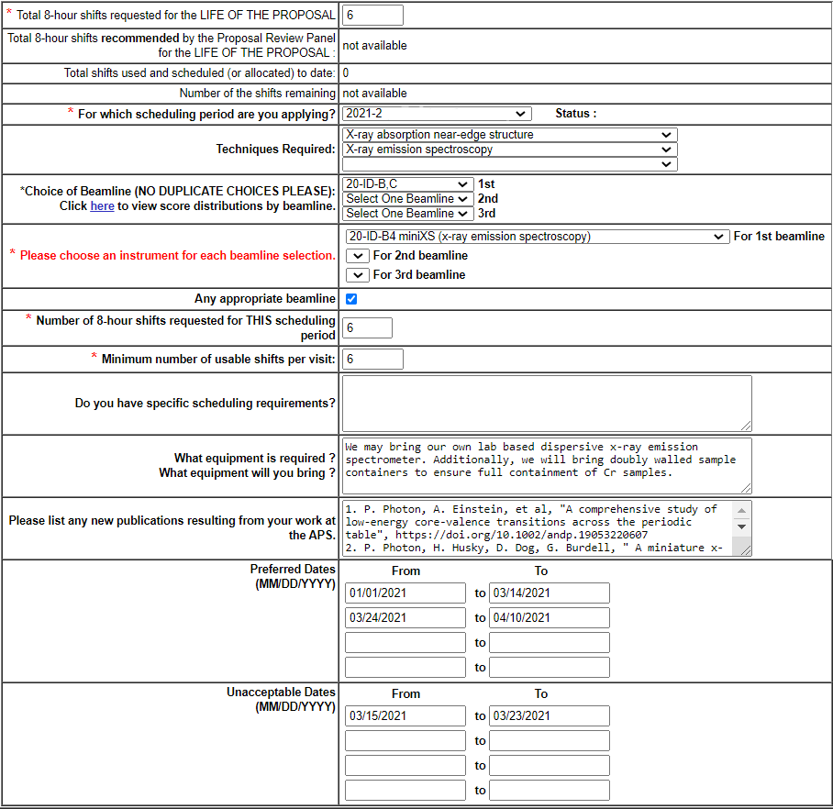

Instructions: Below, give your responses to the beatime request questions. What’s your starting guess for the number of shifts you will need? What beamline do you want to use at your favorite synchrotron? Do you have a backup if your first choice beamline is not available? Do you need any specialized equipment or will you be bringing any yourself?

1. Additional questions: This portion is to help the committee to get a more detailed idea about specific aspects of your proposal -- despite the secondary-sounding title, together with the abstract this is the heart of the overall proposal. Note that the APS general user proposal which our template is based on includes additional questions about content which may overlap with what you discuss in the abstract section. It is okay to repeat some of the information that you covered in the abstract portion. A few small notes: (1) Not every question from the official APS proposal “additional questions” section is included here, as some of them are very individual specific and will provide little insight into the overall proposal writing process; (2) Some of the questions that we do include in this section only require 1 or 2 sentences to answer completely, so do not feel pressured to use the entirety of the allotted word limit.

Instructions: For each question, the prompt for the actual question in the proposal is shown in bold. Following this is a small amount of advice or additional prompting questions to help get you thinking about what to include in your response. Finally, an example response is provided. In the space provided beneath each example, give a response for your own mock proposal topic.

**Question 1: If this work is a continuation of work done under a previous proposal, give the previous proposal number and indicate what changes have been made. (limit: 3000 characters).**

Example:

*This work is a continuation of a Cr oxidation state XES study on plastics (GUP ID 74719). In this proposal we intend to study a different class of materials which also contain hazardous Cr oxidation states, namely soil samples from paint factories. The prior work resulted in a manuscript under preparation.*

**Question 2: What is the scientific or technical purpose and importance of the proposed research? (limit: 500 words).** This particular question may overlap significantly with the material that you cover in the abstract section. However, this is a good chance to go more in depth on the significance of your experiment, the reasoning behind studying it, and impact that it will have in the field.

The APS proposal has a supplementary materials section where figures can be included which are then referred to throughout the proposal. This question and the abstract are good places to include references to any supplementary material you include. However, be aware that you should only attach figures which are directly related to or support the discussions within your proposal, such as figures which demonstrate preliminary work or highlight a particular point which is difficult to explain with words. You *should not* include additional text that you did not have space for in your abstract or elsewhere in your proposal.

Example:

*In the abstract, we motivated the overall scientific case for a comparison of four independent modes of XAS applied to one problem: the speciation of Cr in contaminated soils. Here we focus on the technical issues involved, with an eye toward illustrating the complementary sensitivities of K⍺ XES, K*𝛽 *XES, and VTC-XES, and XANES -- see Figures 1 to 3 in the supplementary materials. First, as shown in Fig. 1, the change in K⍺ consists of modest shifts position and width of both the K⍺1 and K⍺2 lines. This is the weakest of the various signatures, but may be the most reliable since the deep core-to-core transition is strongly insensitive to ligand details. Next, in Fig. 2 we see that the dependence of the K*𝛽*1,3 line (3p to 1s) has a clear shift of the peak position towards lower energy with increasing oxidation state and will also have a quenching of the K*𝛽*’ satellite (not shown because of energy range limitations in that study). Moving on, the VTC-XES (Fig. 3) is roughly 30 times smaller than the K*𝛽*1,3 lines but demonstrates some fingerprints that correlate with oxidation state, although the poor energy resolution of the prior work (~4 eV) makes it impossible to see, e.g. the known changes in the valence-level electronic structure when underground a transition from octahedral (Cr2O3) to tetrahedral Cr(VI). Finally, the Cr(III) and Cr(VI) XANES spectra is illustrated in Fig. 4, where the strong Cr(VI) pre-edge peak provides a clear method of distinguishing between the two oxidation states. The systematic errors association with these four analyses should be strongly independent. This both serves to enhance the reliability of our inferences and also allows us to address the long-standing issue of the validity of XANES linear-superposition analysis for oxidation state analysis.*

*Hence, to summarize, the scientific focus of our work (abstract) centers on the importance of Cr speciation for environmental considerations, and this motivates the careful technical aspects (described above). We anticipate that the resulting publication will be of interest both to the specialist community interested in Cr in the environment and also the broader XAS community.*

**Question 3: Why do you need the APS for this research? (limit: 100 words).** Why do you need this particular facility over a different one? Do they have a specific beamline that you want to use? Do you have a particular need to be at this facility?

Example:

*We need the very high flux of a synchrotron for some of the XES of more dilute samples and also definitely need synchrotron beamtime for the XANES measurements in fluorescence mode.*

**Question 4: Why do you need the beamline you have chosen? (limit: 100 words).** This is similar to the previous question. Show the committee that you’ve done your research about the right beamline for your experiment. Does this beamline allow for a particular technique or sample environment that your experiment requires?

Example:

*The specific beamline requested has equipment for XES, in addition to being well-equipped for the desired fluorescence-mode studies of XANES in the needed energy range. The beamline support staff is strongly experienced with the XES instrumentation and its support software.*

**Question 5: Describe the participants' previous experience with synchrotron radiation and the experimental results obtained. (If you refer to previous publications, be sure to include complete citations.) (limit: 100 words).** This question is mainly to provide some context about the synchrotron background of the *entire team* involved in the study. Give one or two lines which summarize the number of years and level of expertise each of the participants in the proposal have. You have to show that your team has the skills needed to perform the study and alsoanalyse the resulting data en route to publication.

Example:

*The research supervisor, Prof. Photon has more than 20 years experience in synchrotron studies using x-ray spectroscopies and x-ray scattering methods.*

*Graduate students Dubs The Dog, Harry the Husky, and George Burdell each have 3 years experience at various APS beamlines, and have all received considerable training in the required data analysis techniques (such as used in prior publications for EXAFS or XES).*

*Although not listed as an ‘experimenter’ participant, we note that Prof. Theorist is part of our collaboration and will assist with TDDFT calculations.*

**Question 6: Describe samples and explain the proposed experiment, including procedures. Explain the basis for your estimated beam time needs. (limit: 500 words).** This is a good place to go into specifics of what data you plan on taking and how. Exactly what materials/samples will you be studying? How will they be prepared? Will you be augmenting any detectors, designing any specialized sample environments, or performing some novel technique? Overall, what is your game plan for the study? Showing that you are organized and have a well thought experiment is key to a successful proposal. You should demonstrate your understanding of the system you are studying by discussing how you will overcome potential roadblocks and/or improve upon prior work. You should provide an estimate of how long each measurement will take -- this is background information needed to answer question 7, for which there will probably be some repetition.

Example:

*We will perform high resolution XES and XANES measurements on select Cr materials of 3 classes: Pure compounds, mixtures of compounds, and validation samples. The pure (>99.9%) compounds will have only a single chromium oxidation state. The mixtures of compounds will be prepared prior to arriving at the synchrotron and will be composed of mixtures of the pure compounds (ex: 50% pure BaCrO4 and 50% pure Cr2O3). Finally, the validation samples will be well studied environmental samples (NIST SRM 2701 and NIST SRM 2706). There will be a total of 20 samples. This will allow for a large enough data set to adequately test our four chosen methods. Samples will be prepared in doubly sealed containers to ensure full containment of Cr samples. For XANES we will use the standard beamline configuration with a SDD detector for fluorescence-mode detection. We anticipate that each sample will require 30 minutes to 1 hour for XANES data collection. The emission spectrum of the K⍺, K*𝛽*, and VTC lines for each sample will use two different miniXES detectors (one for Ka and one for the region spanning Kb and the valence level). The Ka measurements will be fast, but the Kb/VTC studies will require as much as 4 hours per sample (when it can be detected).*

**Question 7: Provide an overall estimate of the amount of beam time you will need to accomplish the goals of your proposed experimental program. How many visits during the two-year proposal period do you expect to need? How many shifts will you need during each visit (approximately)? (limit: 500 words).** A couple general methods for answering this question are: (1) Use a past study with a known time to complete to approximate how many shifts/visits are needed; (2) Estimate how long it takes to measure one “unit” (usually a single sample) for your setup, and then extrapolate based on the number of units you plan on studying.

Example:

*The setup of the spectrometer and calibration of its energy scale will take about 3 hours. The samples can be split into two classes: reference compounds (high concentration) and research samples (typically at the 10 ppm level). Measurement times for reference compounds are short, but they need to be repeated to check for any calibration drift -- we estimate a total of 4 hours spread over the full 6 shifts (2 days) of the effort. On the basis of our prior work and discussions with the beamline scientist, the dilute research samples will take 1 hour per sample to measure. We will measure 20 research samples, so in total, we estimate the entire experiment to take 24 hours (3 shifts), but given potential inefficiencies or calibration issues, checking for reproducibility, ect, we request 6 shifts to allow for some small margin of error in these estimates.*

**Question 9: List publications resulting from work done at the APS. Please identify the beamline(s) where the work was done. (limit: 2000 characters).**

Example:

*Beamline: 16-ID-D*

*P. Photon, H. Husky, M. Plank, et al., Analytical Chemistry, vol. 78, no. 12, 2015, pp. 1324–5678.,* [*https://doi/10.1021/acs.analchem.8b00302*](https://doi/10.1021/acs.analchem.8b00302) *.*

**Question 10: References (limit: 2000 characters).** The last question in the APS form is actually a place to list citations. If you’ve done a good job of including relevant citations in your abstract and the scientific motivation, then chances are that you will run out of space here. Keep in mind that there is no need here to follow detailed citation formats that you would use in a journal article. One piece of advice: If you include digital object identifiers (DOI’s) then it makes it easier for proposal review panel members to access a citation if that proves helpful to them!

[1] Off. J. Eur. Union. 2011;54:88–110

[2] Unceta, N., et al. *Analytical and Bioanalytical Chemistry*, vol. 397, no. 3, 2010, pp. 1097–1111., <https://doi.org/10.1007/s00216-009-3417-1> .

[3] Jahrman, Evan P., et al., *Analytical Chemistry*, vol. 90, no. 11, 2018, pp. 6587–6593., <https://doi/10.1021/acs.analchem.8b00302> .

[4] Malherbe, Julien, et al., *Environmental Science & Technology*, vol. 45, no. 24, 2011, pp. 10492–10500., <https://doi.org/10.1021/es201002g> .

[5] Gendusa, Tonyc., et al., *Bulletin of Environmental Contamination and Toxicology*, vol. 50, no. 1, 1993, <https://doi.org/10.1007/bf00196553> .

[6] Malherbe, J., and F. Claverie., *Analytica Chimica Acta*, vol. 773, 2013, pp. 37–44., <https://doi.org/10.1016/j.aca.2013.02.035> .

[7] Bergmann, U., et al., *Chemical Physics Letters*, vol. 302, no. 1-2, 1999, pp. 119–124., <https://doi.org/10.1016/S0009-2614(99)00095-0> .

Below we include our figures which are referred to in the “Additional questions” section under the question: What is the scientific or technical purpose and importance of the proposed research? These would normally be attached as a part of a separate “supplementary materials” document and are intended to support the written portions of your proposal.

Figure 1: Cr Ka XES of selected trivalent and hexavalent reference Cr compounds after background correction and integral normalization.

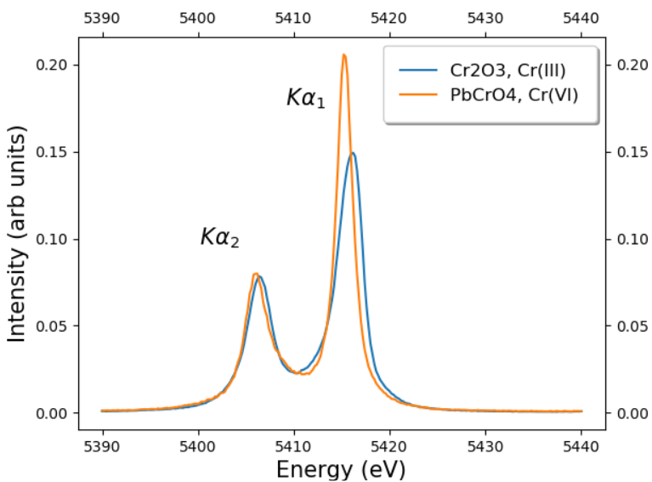

Figure 2: Adapted from reference [6]

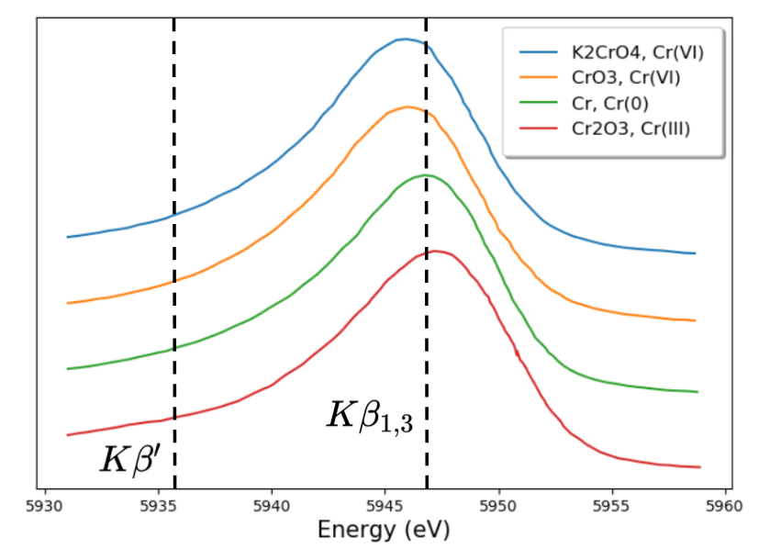

Figure 3: Adapted from reference [6]

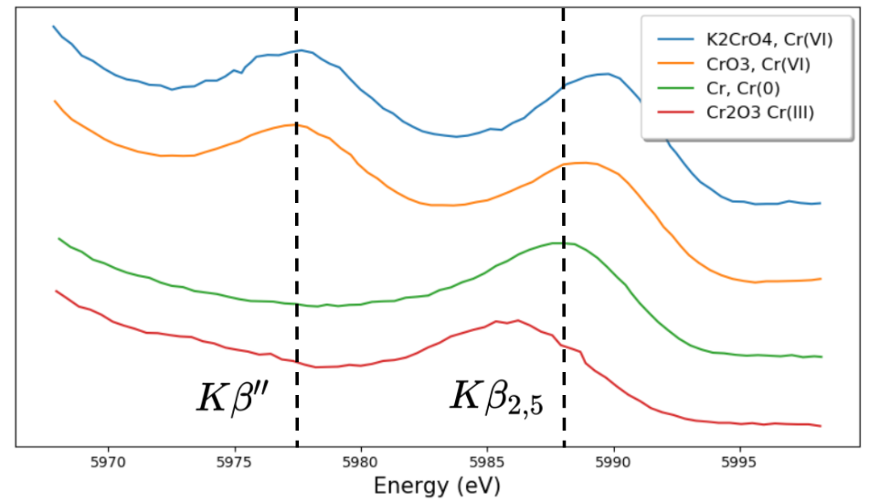

Figure 4: Foster, Andrea L. *Improvement of a Cr(VI) Extraction Method for Chromite Ore Processing Residue (COPR)-Contaminated Materials*. July 2015, nemc.us/docs/2015/presentations/Thu-Contaminated Sediments-10.2-Wolf.pdf.

